Mazda BT50 Stainless Snorkel to Standard Airbox Installation Instructions:
- Firstly, tape the front drivers guard and inner A-pillar with masking tape (this is to prevent scratches when making the hole).
- Cut the hole out of the template before placing it and taping it on the guard. Use a marker to mark the hole directly on the guard.
- Unscrew and remove the plastic guard liner from under the guard.
- Remove the plastic pipe to the airbox.
- Cut the hole in the guard (we use a 102mm hole saw and flappy disk).
- Use a file to remove any excess steel from around the hole (inside and out).
- You may now need to bend/cut two of the brackets on the inner guard to enable enough clearance for the snorkel.
- Prime the bare steel with paint.
- Run the provided pinch weld rubber around the hole and trim it accordingly.
- Insert the snorkel into the hole to a position it fits best then put the snorkel bracket in the a-pillar and close door. Stand back and make sure it fits and lines up perfectly. Adjust slightly if need be.
- Mount the bracket inside the A-pillar using the nutserts provided. You will need 9mm holes for the nutserts.
- Connect the snorkel to the airbox using the 4”-3” 90° silicon join, trim 25mm off the 3” end and slide onto the airbox
- Spray wd40 onto the (outside) end of the snorkel so it slides into the silicon join easily.
- Install the hose clamps on both ends of the silicon join
- Re-install the plastic guard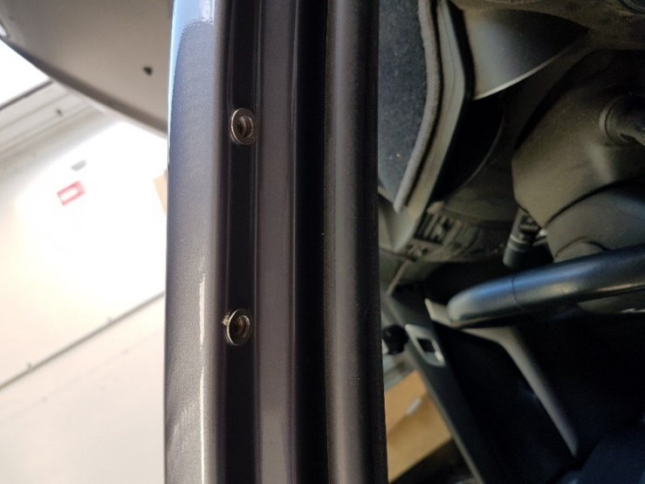 liner under the guard.
