IC-SETRAN-1BK
Mazda BT50- Ford ranger 3.2L or 2.2L

CHECK YOUR PACK LIST
Once you have unpacked the intercooler from the box make sure you have all parts that are listed on the packing list below.

RANGER/BT50 3.2L
QTY | PART | DESCRIPTION
1 | IC-RAN-1 | RANGER INTERCOOLER UNIT
1 | IC-SHS250 | 2.5" SILICONE HOSE STRAIGHT
2 | IC-SHS225 | 2.25” SILICONE HOSE STRAIGHT
1 | IC-RANSIL-1 | 90DEG 2.25" SILICONE
1 | IC-RANPIPE-1 | RANGER HOT PIPE
1 | IC-RANPIPE-2 | RANGER COLD PIPE
8 | IC-Clamp40s30 | CLAMP 57-79mm
2 | IC-SPACER-1 | M6x3mm SPACER

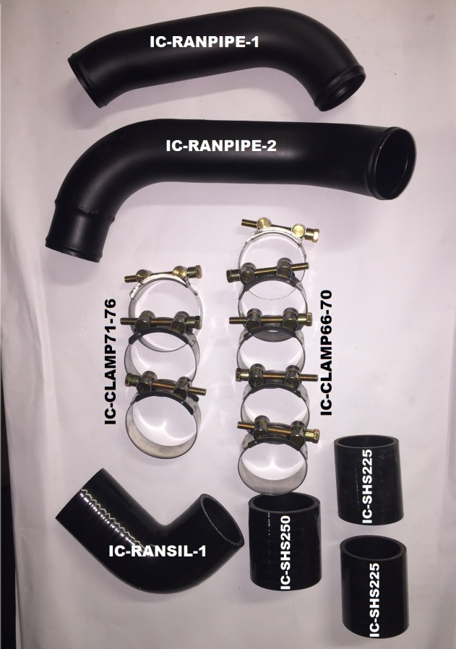
TOOLS REQUIRED:
Removal & Installation
- 10mm & 12mm drive ratchet
- 10mm & 12mm long extensions
- T27 Torx bit screwdriver
- 5mm Allen key
- Flat head screwdriver
- Philips head screwdriver
- Spray lube (e.g. WD40, Innox)
- Portable light

IMPORTANT:
- Take care when handling the intercooler as the fins can easily be damaged.
- It’s very important to check that you have all the components before you start.
- Before installing your intercooler, park your vehicle on level ground ensuring it is in gear (or Park) and the handbrake is applied.
- Wear protective clothing including eye wear when installing the intercooler kit.
- Wait until the vehicle’s engine has completely cooled BEFORE you begin to remove the existing intercooler.

Removing intercooler
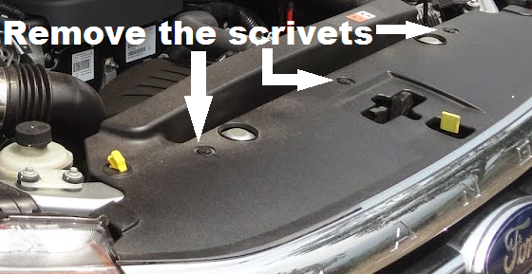

- With a flat blade screwdriver, raise the heads of the scrivets that retain the top main front grille cover tray and remove rivet assembly.

- Remove the lower grill clips (x5). Now remove the grille and upper shield set together.

***If your vehicle has a bulbar you may need to separate the grille cover tray from the grille itself***

- Now loosen the standard hose clamps on both side. (loosen only, Don’t need to remove just yet)

- Remove the x2 air ducts, use a the 10mm ratchet, to remove the 4 bolts, then with a screwdriver remove the small scrivet. On the bottom of the passenger side air duct there may be another air temp sensor. This will have to be unclipped for the air duct to be removed. Now remove the air ducts.

***If your vehicle has a bulbar you may need to remove the passenger side head light to give yourself enough room to remove the grille and have enough access to the air ducts***

- Release the air temp sensor clip, but keep the sensor in the intercooler for now. This is located on the passenger side of the intercooler.

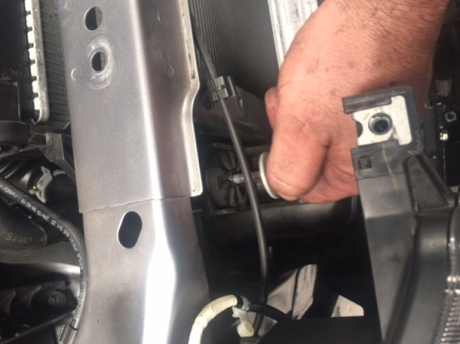

- Remove the 4 mount nuts washers and rubbers, with a 10mm socket. Keep the intercooler in place for now.

- Remove the x2 headlight brackets both driver side & passenger side. Start with the 10mm bolt, next the scrivet, and the long T27 screw. Now the 12mm bolts, one is inside the engine bay, the other is reachable from underneath the 4wd. Once this has been done, you can remove them.

- Now you can remove the intercooler, it’s easiest to pull it forward off the mounts and raise the passenger side out first.
Installing Your New Big boy intercooler

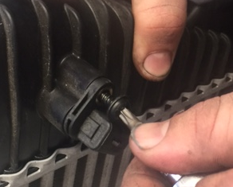
- Using the T27 Torx bit, carefully remove the air temp sensor from the original intercooler (passenger side tank). Put a small amount of grease on the O-ring on the sensor and slide into your new Big boy intercooler. Tighten with the allen key bolt supplied.

**be careful not to damage the O-ring**
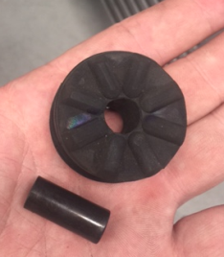

- Put the 4 rubber mounts into the new intercooler brackets

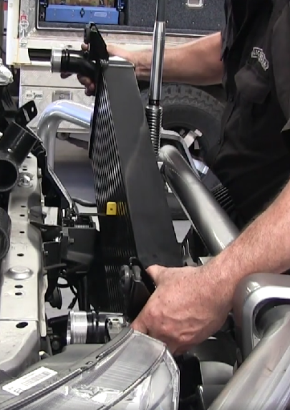

- Now mount the new intercooler into place. It may be easier to put the driver’s side in first then the passenger side then onto the mounts. Before tightening the intercooler into place check the clearance on the bonnet latch support as some MK2 need to use the spacers to help clear the bonnet latch. Tighten the 4x10mm bolts once you are happy with the position.

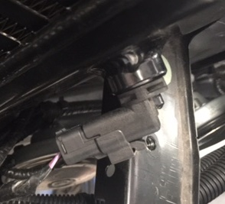
- This step is VERY IMPORTANT to do now-- Reconnect the air temp sensor, wiring loom together.

- Refit the headlight brackets, in reverse of the removal.

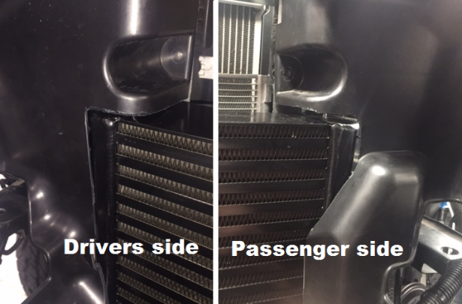
PX2 RANGER Air Ducts shown
- Now that the intercooler is in place is time to do a small mod to the air ducts. With a hacksaw, you’ll need to trim the top, front & bottom edges. Make sure there is a few mm clearance, and reinstall, both sides, using the standard bolts.

**The different models will require different amount of trimming on the air ducts**

- Install hot pipe(IC-RANPIPE-1) using 2x staright silicone hoses(IC-SHS225) and 4x hose clamps(IC-CLAMP40s30) on the passenger side. Put 1silicopne hose onto the lower pipe and 1 onto the intercooler with tha clamps slid onto the silicone but not tight. Install the pipe into the lower silicone first the into the top silicone second. Once happy with the position you can now tighten the clamps.

**it may be easier to access the lower clamps form the inner guard through the rubber flap**

***Make sure when tightening the hose clamps the threded section is not going to rub through or vibrate on anything***

- Now fit the 2.25” silicone 90-degree bend (IC-RANSIL-1) to the intercooler, put the long leg onto the intercooler outlet using 2x hose clamps (IC-CLAMP40s30).

- Put the 2.5” straight silicone hose (IC-SHS250) onto the throttle body using 2x hose clamps(IC-CLAMP40s30).

- Now fit the cold pipe (IC-RANPIPE-2) by putting it onto the throttle body first the putting it into the intercooler and last. Once happy with it position you can begin to tighten the clamps.

***Make sure when tightening the hose clamps the threded section is not going to rub through or vibrate on anything***

- Re fit the grill back into place, with the original clips.

- Now for the Test. turn your engine on and give it a few revs of the accelerator. You are listening for air leaks. Next you want to check all the silicone, and clamps are in place. Check all parts for good clearances. Now go for a short drive to make sure everything is correct.

Final checks once BigBoy is fitted
Now that your intercooler is fitted to the vehicle do a final check over of the system:
- Make sure all the factory mounts and bolts, and clips have all been used.
- Double check all bolt, and clamps are tight.
- You may now start the vehicle and run at idle for a couple of minutes.
- Listen for any air leaks.
- Now the vehicle is ready for a test drive. Once returning from test drive and vehicle has cooled check all nuts bolts, some may need re- tightening, and clamps can be inspected.
- Also, re-check tightness of the bolts after 20-50km

Now get out there and enjoy your new Big BOY intercooler.

